執行底下語法，帶入適當的參數，並將結果複製，可再次依照條件進行篩選產生Update SQL語法

declare @schemaname varchar(30)='**comm**'  
declare @tablename varchar(50)='**tb_code**'  
declare @where_condition nvarchar(350)=''  
select [comm].[fn_gen_update_value_ext_sql] (@schemaname,@tablename,'')

**第一次查詢結果**

SET CONCAT_NULL_YIELDS_NULL OFF  
select cast(  +' update  comm.tb_code ' +char(13)+char(10) +'SET code_type='+CASE WHEN tb.[code_type] IS NULL THEN 'NULL' ELSE ''''+replace(tb.[code_type],'''','''''')+''''END +char(13)+char(10)  
+',code_no='+CASE WHEN tb.[code_no] IS NULL THEN 'NULL' ELSE ''''+replace(tb.[code_no],'''','''''')+''''END +char(13)+char(10)  
+',code_desc='+CASE WHEN tb.[code_desc] IS NULL THEN 'NULL' ELSE 'N'''+replace(tb.[code_desc] COLLATE Chinese_Taiwan_Stroke_CI_AS,'''','''''') +''''END +char(13)+char(10)  
+',creator='+CASE WHEN tb.[creator] IS NULL THEN 'NULL' ELSE ''''+replace(tb.[creator],'''','''''')+''''END +char(13)+char(10)  
+',create_time='+CASE WHEN tb.[create_time] IS NULL THEN 'NULL' ELSE 'cast('''+convert(varchar(30),tb.[create_time],121)+''' as datetime2)'END +char(13)+char(10)  
+',modifier='+CASE WHEN tb.[modifier] IS NULL THEN 'NULL' ELSE ''''+replace(tb.[modifier],'''','''''')+''''END +char(13)+char(10)  
+',last_update_time='+CASE WHEN tb.[last_update_time] IS NULL THEN 'NULL' ELSE 'cast('''+convert(varchar(30),tb.[last_update_time],121)+''' as datetime2)'END +char(13)+char(10)  
+' where code_key='''+replace(code_key,'''','''''')+''''+'' as varchar(4000)) as data   
 from comm.tb_code tb--共用代碼檔

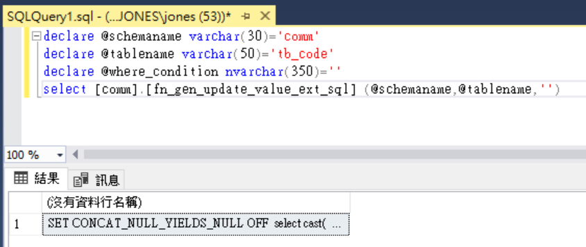

將第一次結果，加入篩選條件後執行後，選取所有資料列複製即可取得update sql 語法，

SET CONCAT_NULL_YIELDS_NULL OFF  
select cast(  +' update  comm.tb_code ' +char(13)+char(10) +'SET code_type='+CASE WHEN tb.[code_type] IS NULL THEN 'NULL' ELSE ''''+replace(tb.[code_type],'''','''''')+''''END +char(13)+char(10)  
+',code_no='+CASE WHEN tb.[code_no] IS NULL THEN 'NULL' ELSE ''''+replace(tb.[code_no],'''','''''')+''''END +char(13)+char(10)  
+',code_desc='+CASE WHEN tb.[code_desc] IS NULL THEN 'NULL' ELSE 'N'''+replace(tb.[code_desc] COLLATE Chinese_Taiwan_Stroke_CI_AS,'''','''''') +''''END +char(13)+char(10)  
+',creator='+CASE WHEN tb.[creator] IS NULL THEN 'NULL' ELSE ''''+replace(tb.[creator],'''','''''')+''''END +char(13)+char(10)  
+',create_time='+CASE WHEN tb.[create_time] IS NULL THEN 'NULL' ELSE 'cast('''+convert(varchar(30),tb.[create_time],121)+''' as datetime2)'END +char(13)+char(10)  
+',modifier='+CASE WHEN tb.[modifier] IS NULL THEN 'NULL' ELSE ''''+replace(tb.[modifier],'''','''''')+''''END +char(13)+char(10)  
+',last_update_time='+CASE WHEN tb.[last_update_time] IS NULL THEN 'NULL' ELSE 'cast('''+convert(varchar(30),tb.[last_update_time],121)+''' as datetime2)'END +char(13)+char(10)  
+' where code_key='''+replace(code_key,'''','''''')+''''+'' as varchar(4000)) as data   
 from comm.tb_code tb--共用代碼檔

where code_type='000'

第二次執行結果即產生更新資料表語法

 update  comm.tb_code  
SET code_type='000'  
,code_no='000'  
,code_desc=N'代碼型態說明'  
,creator='jones'  
,create_time=cast('2013-08-27 00:00:00.0000000' as datetime2)  
,modifier='ADMIN'  
,last_update_time=cast('2019-01-05 15:51:37.5138300' as datetime2)  
 where code_key='000|000'  
 update  comm.tb_code  
SET code_type='000'  
,code_no='001'  
,code_desc=N'檔案類型'  
,creator='jones'  
,create_time=cast('2013-08-27 00:00:00.0000000' as datetime2)  
,modifier='jones'  
,last_update_time=cast('2013-08-27 00:00:00.0000000' as datetime2)  
 where code_key='000|001'  
 update  comm.tb_code  
SET code_type='000'  
,code_no='002'  
,code_desc=N'設定檔匯入模式'  
,creator='jones'  
,create_time=cast('2013-08-27 00:00:00.0000000' as datetime2)  
,modifier='jones'  
,last_update_time=cast('2013-08-27 00:00:00.0000000' as datetime2)  
 where code_key='000|002'  
 update  comm.tb_code  
SET code_type='000'  
,code_no='003'  
,code_desc=N'異常檢核'  
,creator='jones'  
,create_time=cast('2013-08-27 00:00:00.0000000' as datetime2)  
,modifier='jones'  
,last_update_time=cast('2013-08-27 00:00:00.0000000' as datetime2)  
 where code_key='000|003'

